定时器

1. 工作原理

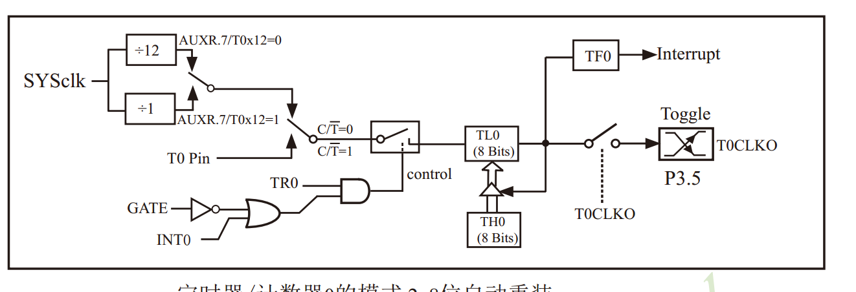



SYSCLK = 11.0592 MHz





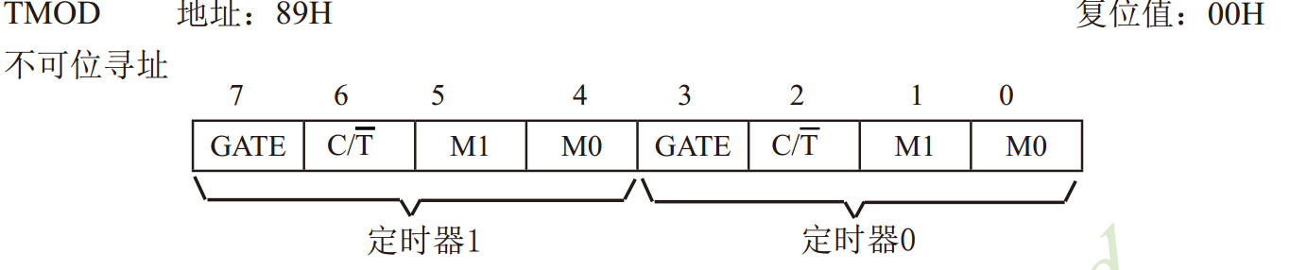

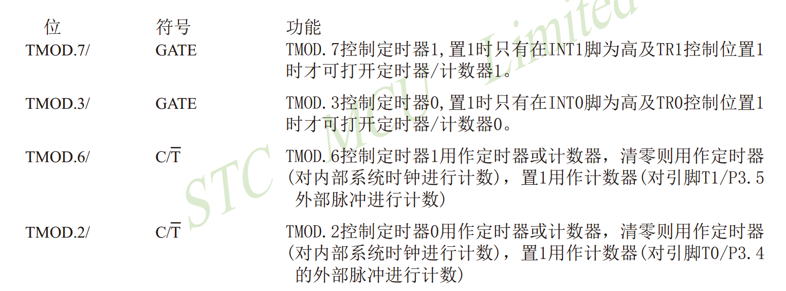

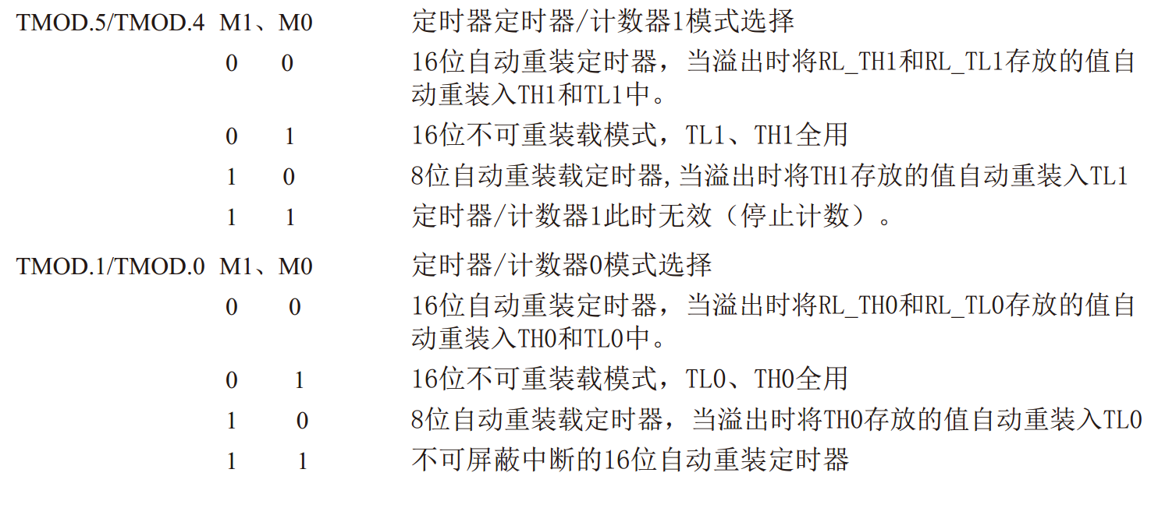

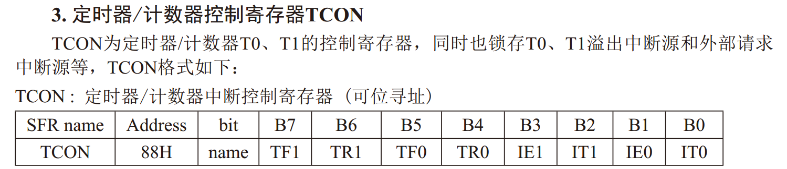



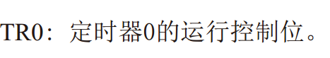



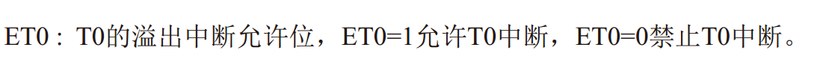

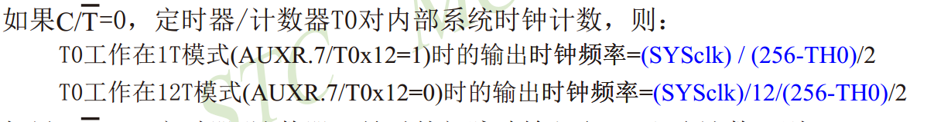

代码：

|  |
| --- |
| unsigned int idata guiTimer1S = 4000;  //unsigned int idata guiTimer1S = 85937;  sbit LED3 = P3 ^ 3;  void timer0int() interrupt 1  {  guiTimer1S--;  if (0 == guiTimer1S){  guiTimer1S = 4000;  LED3 = ~LED3;  }  }  void init_timer0(){    AUXR = 0x80; //timer 0 1T mode  TMOD = 0x02; // internal timer , 8 bit  TH0 = TL0 = 0x00;  TR0 = 1;  ET0 = 1;  EA = 1;    }  void main(){  LED3 = 1;  init_timer0();  while(1);  } |

问题： 如何计算定时器周期